**3. Implementation**

**3.1 Implementation Functionality**

* **User Authentication:** Implement user authentication mechanisms for proctors, students, and administrators to ensure secure access to the application.
* **Dashboard for Proctors:** Develop a dashboard interface for proctors to manage exams, monitor live feeds, communicate with students, and intervene when necessary.
* **Dashboard for Students:** Create a user-friendly dashboard for students to access exams, view instructions, submit answers, and communicate with proctors.
* **AI-Powered Suspicious Activity Detection:** Integrate AI models using OpenCV and TensorFlow/PyTorch for real-time monitoring of exam sessions, detecting suspicious activities such as looking away from the screen or multiple faces in the camera view.
* **Live Camera Feed Monitoring:** Implement functionality to stream live camera feeds from students' devices to proctors' dashboards for real-time monitoring and supervision.
* **Real-Time Communication:** Enable instant messaging functionality between proctors and students within the exam interface using WebSockets or Socket.io for quick assistance, clarification of instructions, or issue resolution.
* **Exam Management:** Develop features for creating, scheduling, and managing exams, including setting time limits, configuring exam settings, and generating unique exam links for students.
* **Submission and Grading:** Implement mechanisms for students to submit exam answers securely and for proctors to grade and provide feedback on submitted exams.
* **Security Measures:** Implement robust security measures to protect user data, prevent unauthorized access, and ensure the integrity of exam sessions.
* **Reporting and Analytics:** Develop reporting and analytics features to track exam performance, identify trends, and generate insights for administrators and educators.
* **User Profile Management:** Enable users to create and manage their profiles, update personal information, and configure notification preferences.

**3.2 Results and Reports**

**Result Generation:** Upon completion of an exam, the system automatically generates results based on the student's responses and performance. Result generation includes calculating scores, identifying correct and incorrect answers, and determining overall performance metrics.

**Real-time Feedback:** During the exam, students may receive real-time feedback on their performance, such as notifications for unanswered questions or time warnings. Proctors can also provide immediate feedback or instructions to students through the chat functionality.

**Customization Options:** Administrators have the ability to customize the format and content of reports based on institutional requirements or preferences.

**Accessibility and Security:** Exam results and reports are securely stored and accessible only to authorized users, ensuring data privacy and confidentiality.

**3.3 Snapshots**

**Backend Snapshots:**

* **Head Position Detection Model**

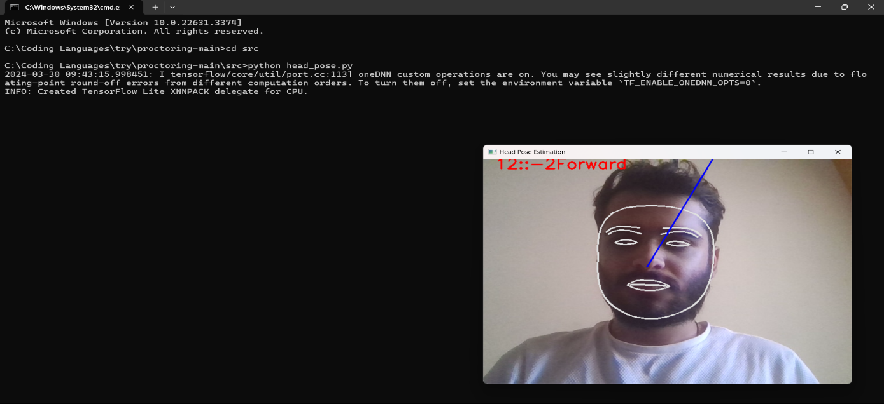

Fig. 3.3 1 Head Position Model

The head position detection model utilizes advanced computer vision algorithms to accurately determine the orientation of human heads within images or video frames. By analyzing facial landmarks and geometric features, it precisely identifies head angles, aiding in applications such as gaze estimation, facial recognition, and augmented reality.

* **User Detection Model**

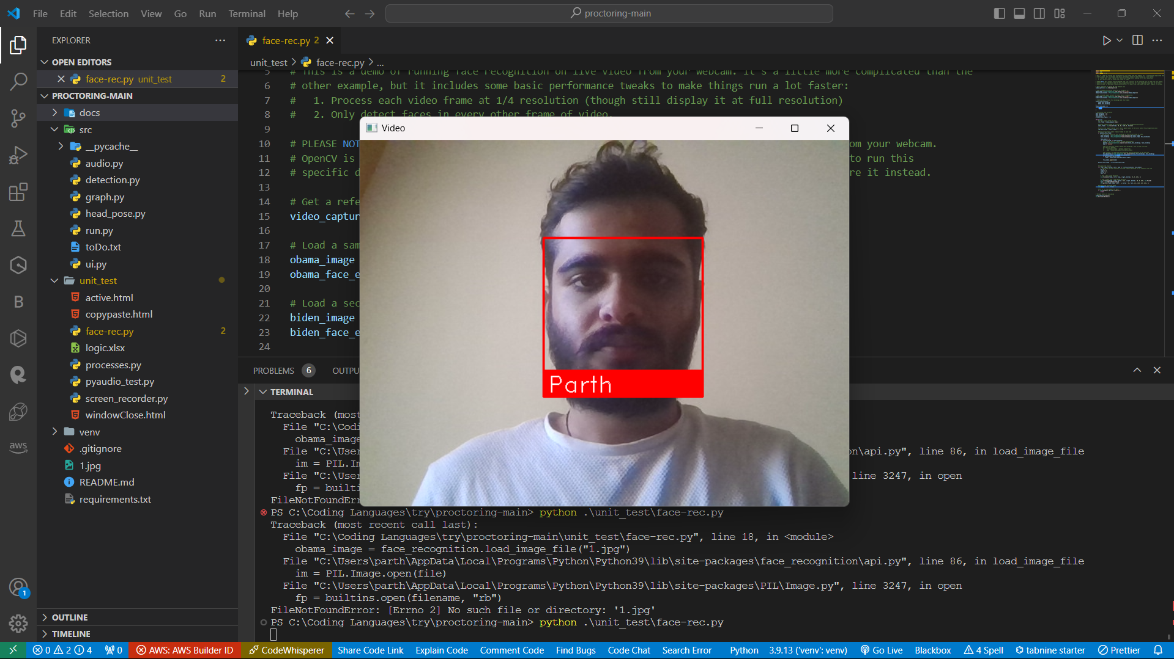

Fig. 3.3 2 Audio Detection Model

The audio detection model employs machine learning techniques to identify and classify various sounds within audio recordings or live streams. By analyzing spectral features and temporal patterns, it can distinguish between different audio events, enabling applications like speech recognition, environmental monitoring, and anomaly detection in audio streams.

* **Screen Recording Model**

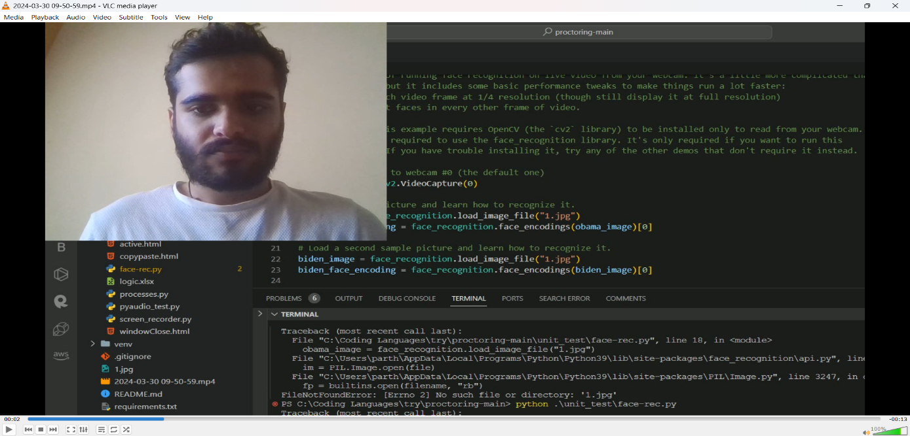

Fig. 3.3 3 Screen Recording Model

The screen recording model leverages deep learning architectures to capture and encode visual information displayed on computer screens in real-time. By analyzing pixel data and frame sequences, it accurately records screen activities, facilitating applications such as tutorial creation, software testing, and user behavior analysis in digital environments.

* **Malpractice Detection Model**

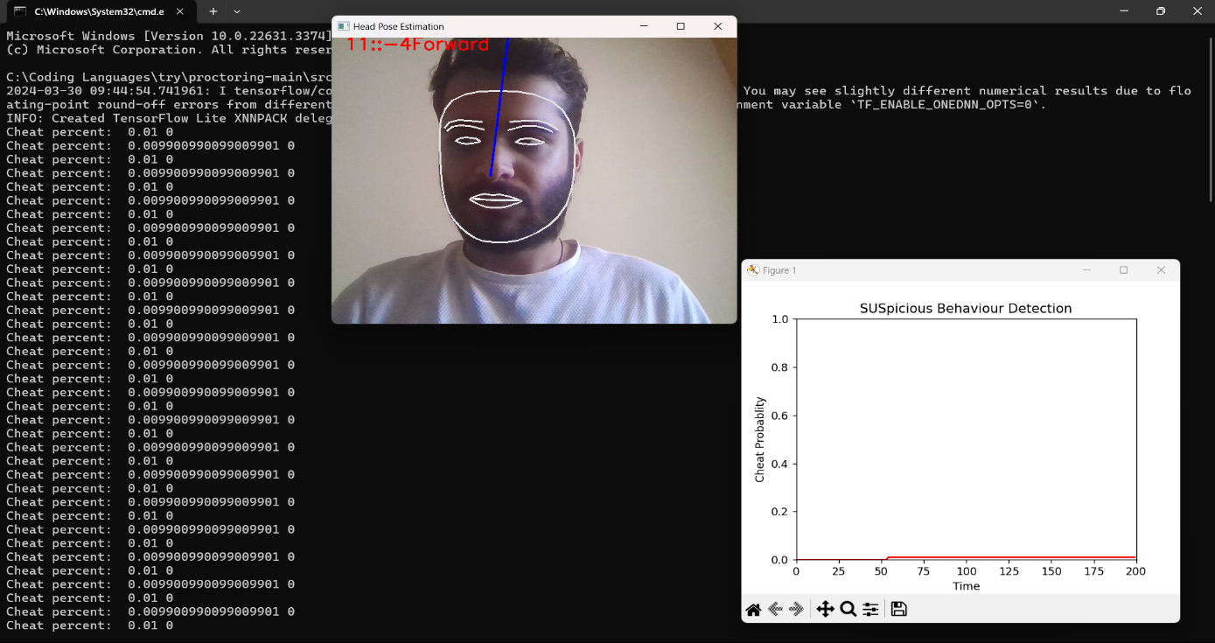

Fig. 3.3 4 Malpractice Detection Model

The malpractice detection model integrates machine learning algorithms to analyze various data sources, such as medical records and practitioner behavior patterns, to identify potential instances of malpractice or negligence. By detecting anomalies, discrepancies, and deviations from established standards, it aids in early intervention, risk mitigation, and quality assurance within professional settings like healthcare or legal domains.

* **Audio Detection Model**

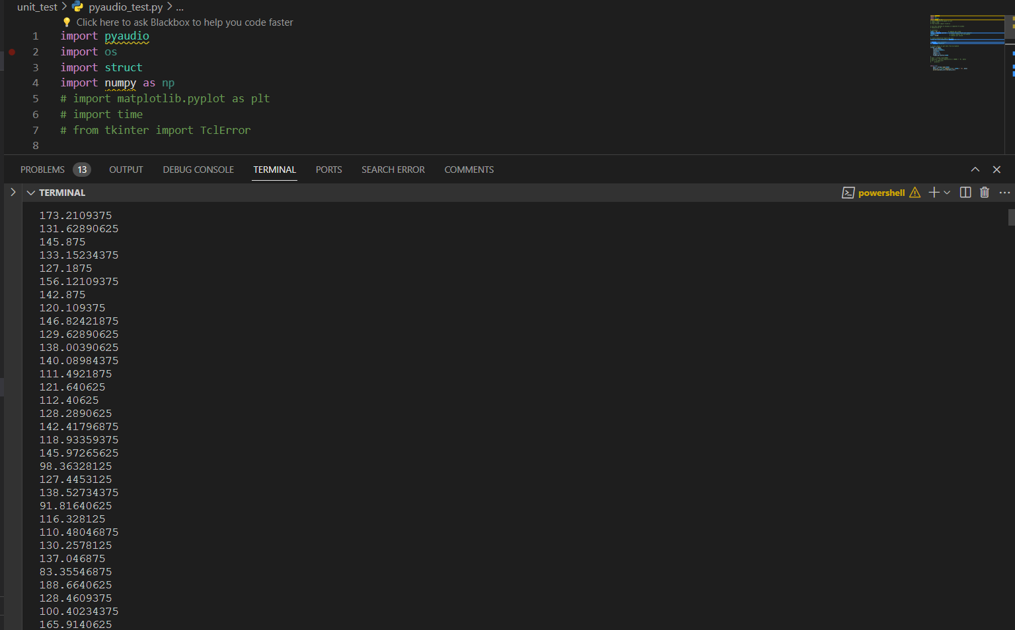

Fig. 3.3 5 Audio Detection Model

The audio detection model employs deep learning techniques to identify and categorize different types of sounds within audio recordings or live streams. By analyzing spectral features, temporal patterns, and frequency characteristics, it can distinguish between various audio events such as speech, music, environmental noise, and anomalies, enabling applications like speech recognition, surveillance, and acoustic monitoring.

**Frontend Snapshots:**

* **Home Page**



Fig. 3.3 6 Home page

The frontend home page presents a visually captivating interface that welcomes users with dynamic content and intuitive navigation, guiding them seamlessly through the website's offerings. Through strategically placed elements and compelling visuals, it creates an immersive experience that encourages exploration and engagement from visitors.

* **Login**

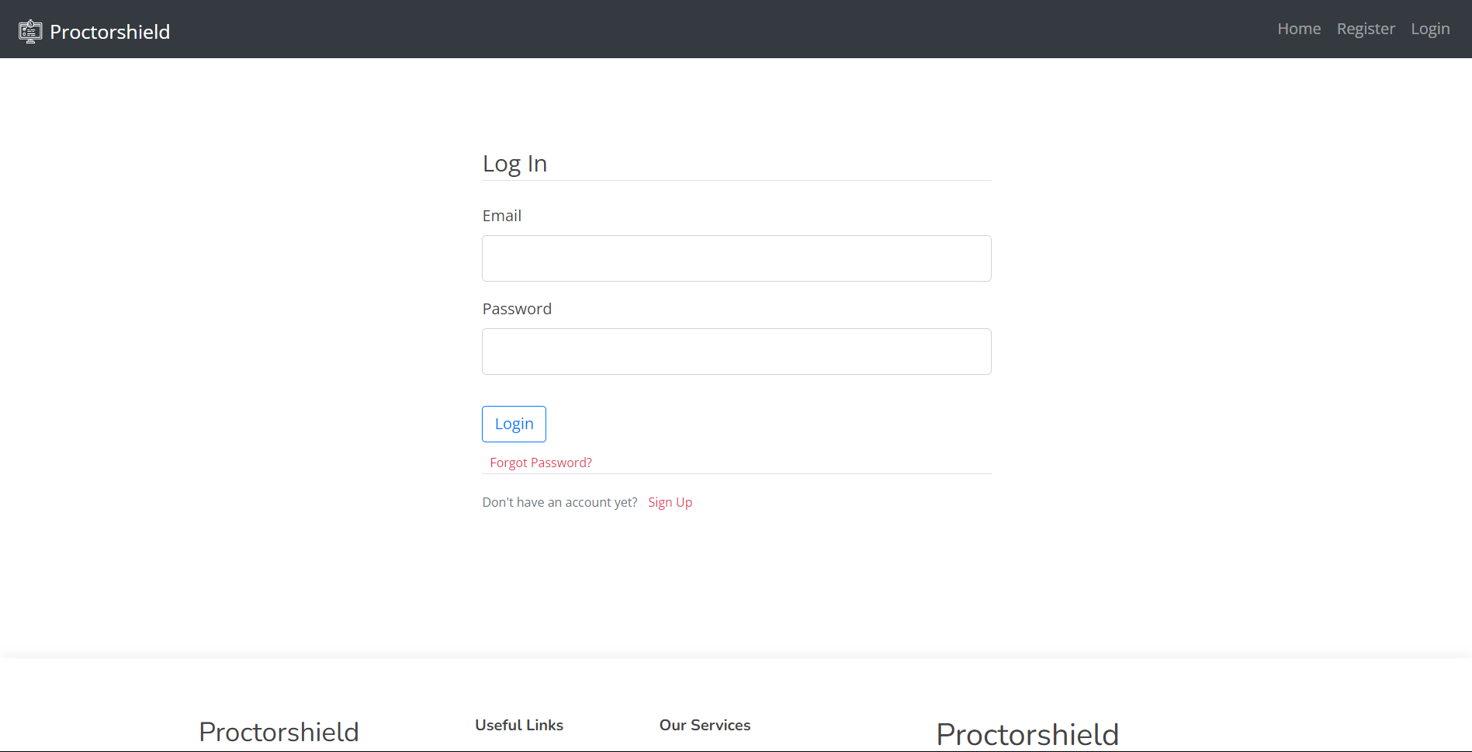

Fig. 3.3.7 Login Page

The login page serves as the entry point for users to access their accounts, requiring credentials such as usernames and passwords for authentication. Designed with user-friendliness and security in mind, it facilitates seamless access while implementing robust measures to protect user information.

* **Dashboard**

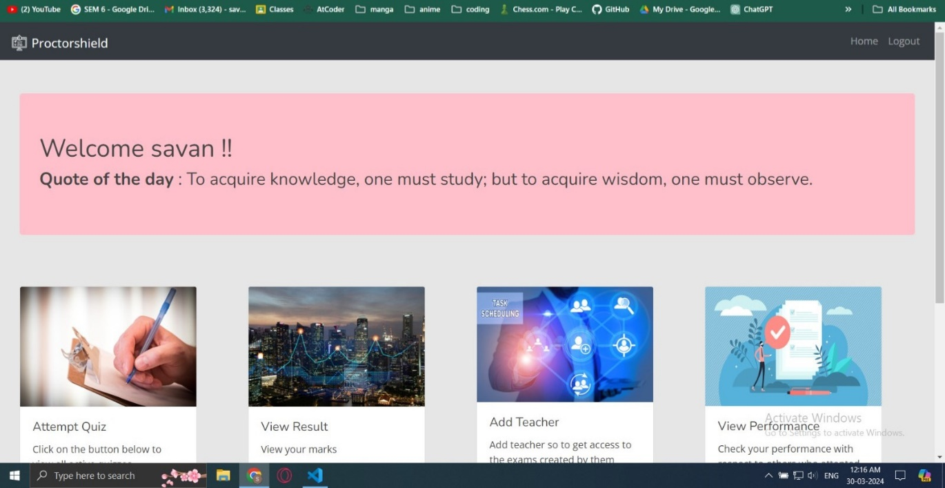

Fig. 3.3.8 DashBoard

The login page serves as the entry point for users to access their accounts, requiring credentials such as usernames and passwords for authentication. Designed with user-friendliness and security in mind, it facilitates seamless access while implementing robust measures to protect user information.

* **Quiz**

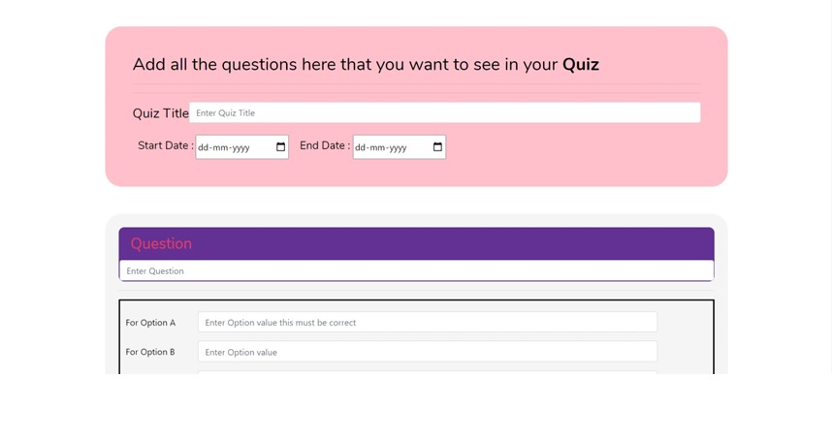

Fig. 3.3.9 Create Quiz

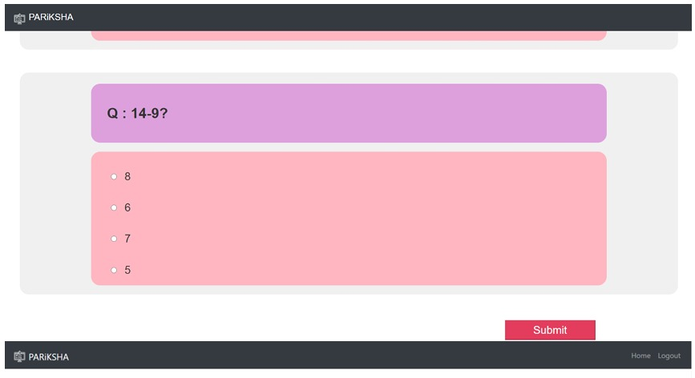

Fig. 3.3.10 Quiz

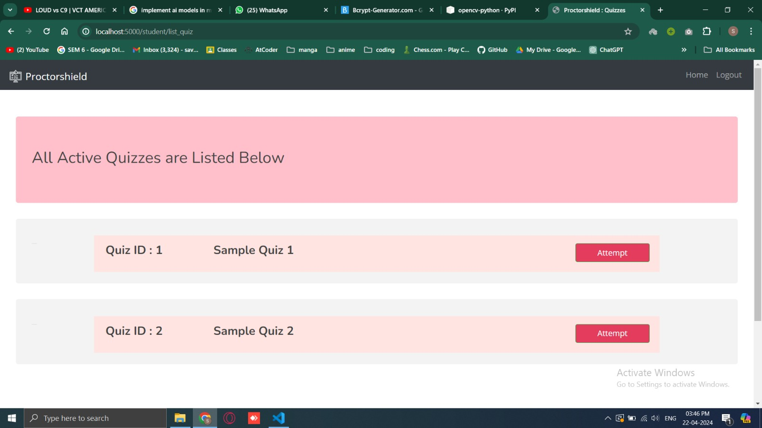

Fig. 3.3.10 List of Quiz

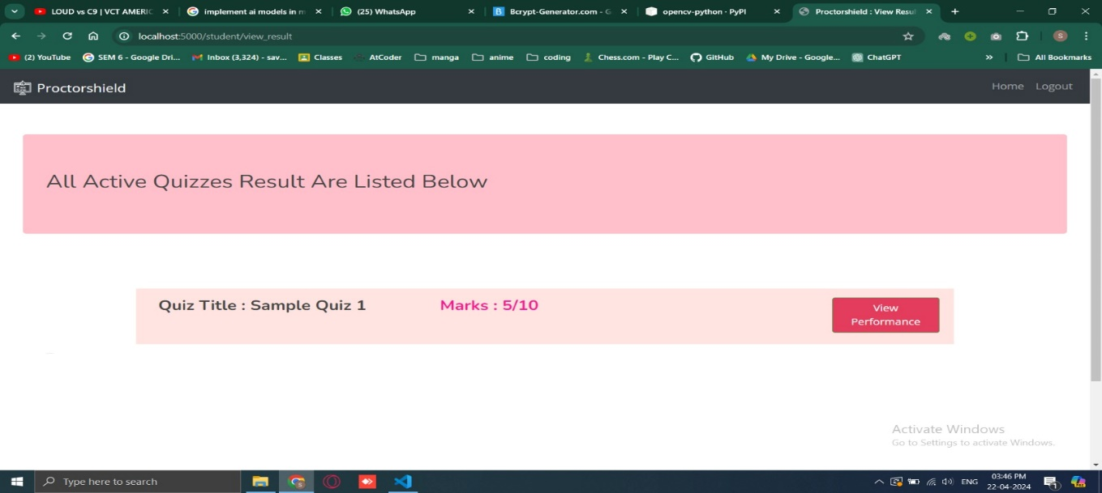

Fig. 3.3.10 Result of Quiz

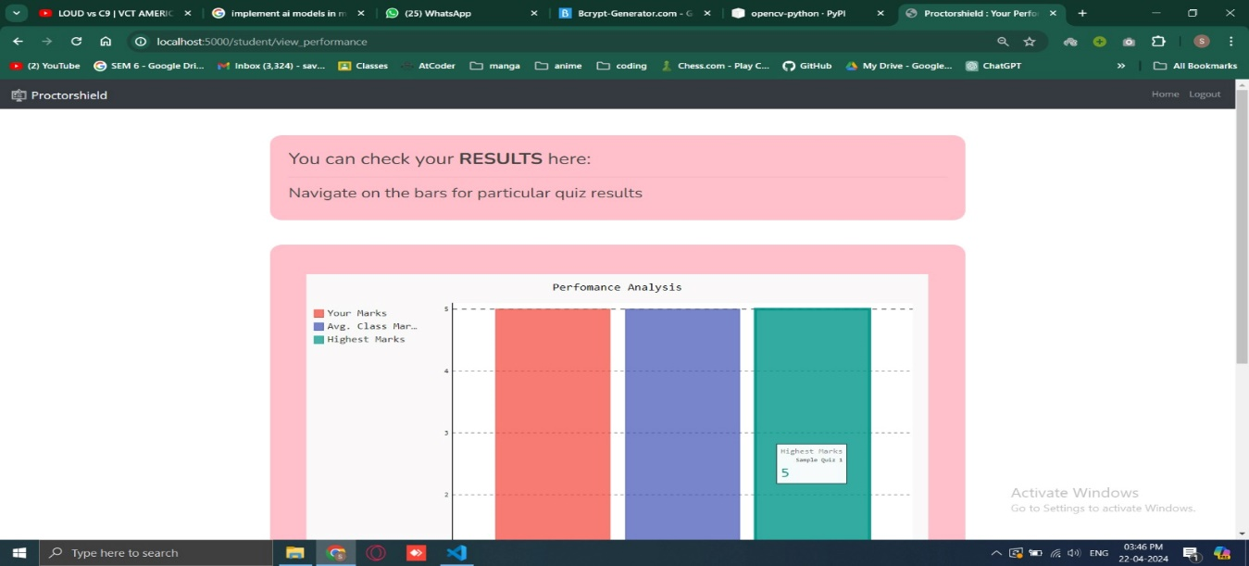

Fig. 3.3.10 Performance Analysis

**3.4 Testing and verification**

**Unit Testing:** Individual components of the application, including backend logic, frontend interface elements, and AI algorithms, will undergo unit testing. Test cases will be designed to validate the behavior of each unit in isolation, ensuring that it functions as intended.

**Integration Testing**: Integrated modules and subsystems will be tested together to verify their interactions and compatibility. This phase will focus on testing the integration of backend and frontend components, communication channels, and database functionality.

**System Testing:** The entire system will be tested as a whole to evaluate its overall functionality, performance, and usability. Test scenarios will be designed to simulate real-world usage scenarios, including exam sessions with multiple users and varying conditions.

**Security Testing**: Security testing will be conducted to identify and mitigate potential vulnerabilities and threats to the application.

**Usability Testing**: Usability testing will be performed to assess the user experience and interface design of the application. Feedback from users will be collected to identify any usability issues or areas for improvement.

**Performance Testing:** Performance testing will evaluate the application's responsiveness, scalability, and reliability under different load conditions. Stress testing and load testing will be conducted to assess the application's ability to handle concurrent user activity and maintain performance.